**Association Rule Mining:**

**Problem statement 2:**

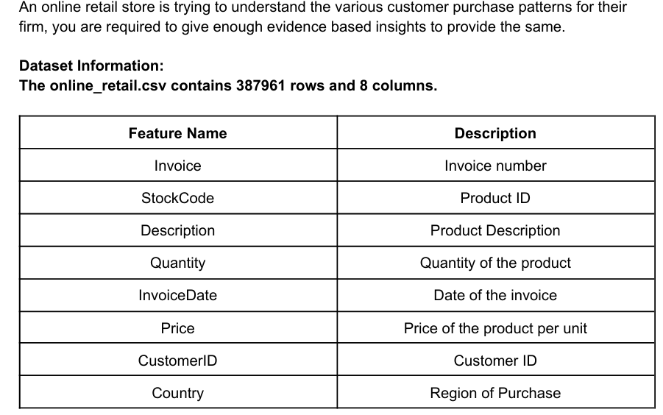

* **Analysis is performed for ‘United Kingdom’**

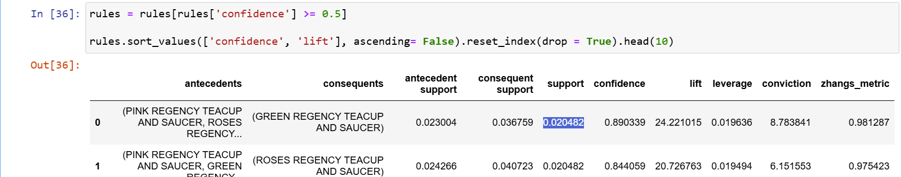

* PINK REGENCY TEACUP AND SAUCER, ROSES REGENCY TEACUP AND SAUCER --> GREEN REGENCY TEACUP AND SAUCER
* Support for PINK REGENCY TEACUP AND SAUCER, ROSES REGENCY TEACUP AND SAUCER is **0.020482**

**That means, PINK AND ROSES REGENCY TEACUP AND SAUCER constitute more than 2% of transaction in United Kingdom**

* Consequent support forGREEN REGENCY TEACUP AND SAUCER is **0.036759 which means, 3.6% of transactions contain GREEN REGENCY TEACUP AND SAUCER**
* Confidence is **0.890339. This indicates, customers who purchase PINK REGENCY TEACUP AND SAUCER and ROSES REGENCY TEACUP AND SAUCER have 89 % chance of purchasing GREEN REGENCY TEACUP AND SAUCER as well**
* **Lift is greater than 1 indicates association is performing better than random chances**